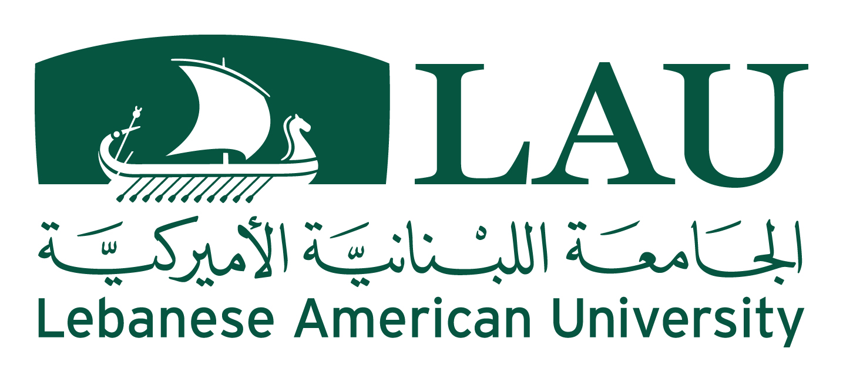
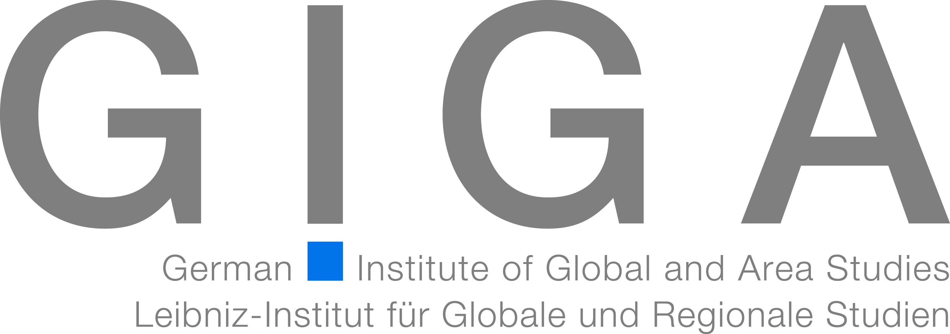
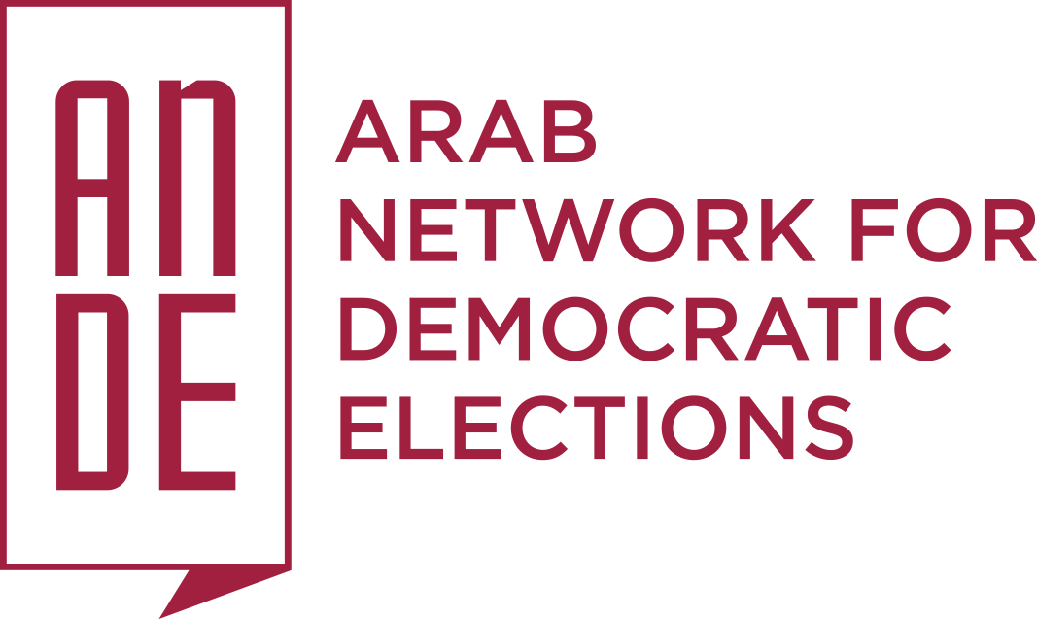

Electoral Law Reforms in Post-Conflict Societies:
The Arab World and Beyond
LAU Byblos Campus, Lebanon
November 24, 25 and 26, 2016

The Arab world is “on fire.” Since the outbreak of the Arab Spring in 2011, people intensified complaints against being disregarded by their rulers and discriminated in the distribution of power. Multiple attempts at reforming Arab countries’ electoral laws have been undertaken since to improve the representativeness of political power. Yet, large segments of populations still do not feel properly represented in political decision-making.
The study of electoral law reform in the Middle East and North Africa (MENA) over the past decade helps us identify the lessons learned and the ones still to be learned. The participants of the conference will discuss how these reforms impact the region’s deeply divided societies, and how they may contribute to mediating conflicts. Special attention will be paid to the electoral law debate in Lebanon, the only Arab country with a long record of democratic practice and a broad occurrence of electoral law modeling. Furthermore, we will raise attention to examples from other world regions and study their experiences.
Now is the right moment to take stock of the progress made in this area and to bring together the knowledge and skills of experts – practitioners and academics – from within and outside the region to assess the progress to date and to foster a debate that will improve elections and social integration well beyond the MENA region. The conference aims to create an academic platform for this discussion that may improve and better mobilize the international community’s support for the democratization and electoral reform processes.
In order to connect different levels of theoretical and practical knowledge about elections and electoral laws, we are inviting:
- Academics from various disciplines studying and comparing electoral systems inside and outside the MENA region;
- Legislators who have participated in the legal framing of electoral processes;
- Representatives of independent expert bodies and ministries managing and supervising electoral processes;
- Political party leaders who are engaged in electoral law reform; and,
- Members of civil society and nongovernmental organizations who are engaged in raising voter awareness, electoral reform advocacy and election monitoring.

Thursday, November 24, 2016

Welcoming Remarks & Introduction to the Conference
9:30–10:00 a.m., Location: Frem Building Room 203-204
Marwan Rowayheb, Chair, Department of Social Sciences, LAU, Lebanon
Nashat Mansour, Dean of the School of Arts and Sciences, LAU, Lebanon
Makram Ouaiss, Assistant Professor, LAU, Lebanon
Ziad Abdel Samad, Coordinator, ANDE, Lebanon
Stephan Rosiny, Research Fellow, GIGA, Germany

Session 1: Challenges of Electoral Law Design in Deeply Divided Societies
10:00 a.m. – 1:00 p.m., Frem Building Room 203-204
11:00 –11:30 a.m. Coffee Break
Electoral reform in deeply divided societies represents an area of real challenge. The first session offers an opportunity to study the obstacles that face such efforts from various perspectives, with the hope of gaining a common understanding of available entry points to pass truly representative, open, and fair electoral systems that respect international standards.

The Best of Both Worlds? Vote Pooling in Consociational Democracies
Matthijs Bogaards, Visiting Professor, Central European University, Hungary

Experiences of Drafting an Electoral Law in a Polarized Environment
Ghaleb Mahmassani , Professor of Law and Former Member of the Boutros Election Reform Commission, Lebanon

Election Commissions’ Experiences: Managing Elections in Tense Post-Conflict Environments
Holly Ruthrauff, Director, Election Observation and Democratic Support (EODS), Belgium

Political Parties: What Role Do and Can They Play in Post-Conflict Environments?
Ivan Doherty, Senior Associate and Director of Political Party Programs, National Democratic Institute (NDI), USA

Civil Society Engagement in Electoral Laws and Election Monitoring in Post-Conflict Countries
Ziad Abdel Samad, Coordinator, Arab Network for Democratic Elections (ANDE)
Moderator: Makram Ouaiss, LAU

Session 2: Experience and Reform of Electoral Laws in Divided Societies in the Middle East and North Africa
2:00–4:00 p.m., Frem Building Room 203-204
The MENA region has experienced various divisions in the past decade and more specifically since the beginning of the Arab Spring. This panel offers an overview of reform attempts and the challenges faced in a number of countries focusing on lessons learned.

Legal Status and Practice of Elections in Tunisia
Mourad Ben Mouelli, Administrative Judge and Vice-President of the Independent High Authority for Elections (ISIE), Tunisia

Quotas or Territorial Autonomy? The Electoral Law Debate in Iraq
Saad Abdulrazzak Hussain, Former Member of Parliament, Member of Iraqi Studies Center, Iraq

Yemen’s History and Practice with Electoral Laws
Mohamad el Mekhlafi, Former Minister of Law and President of the Yemeni Observatory for Human Rights, Yemen

Palestine: Divided in Territory and Ideology
Ashraf Shuaibi, Deputy Chief Electoral Officer, Central Elections Commission, Palestine
Moderator: Marwan Rowayheb, LAU

4:00–4:30 p.m. Coffee break

Keynote Speech
‘Security or Integrity? Conflicting or complimentary values in post-conflict elections.’ 4:30–6:00 p.m., Auditorium (via video conference call)
Pippa Norris, Professor at the John F. Kennedy School, Harvard University, Professor at the University of Sydney, and Director of the Electoral Integrity Project, USA
Introduced by Stephan Rosiny, GIGA

Friday, November 25, 2016

Session 3: Models and Experiences of Electoral Laws from Other World Regions
9:30 a.m.–1:00 p.m., Frem Building Room 203-204
The session draws on the rich practice of countries from other parts of the world that have experienced similar societal and political divisions and have been able to reform their electoral processes. The presentations are an opportunity to compare and contrast these experiences with those of countries in the MENA region.

Electoral Reforms in Indonesia: The Rise of Oligarchs and Populists
Andreas Ufen, Senior Research Fellow (GIGA), Germany

Nepal: Presentation Title
Neel Kantha Uprety, Former Chief Election Commissioner, Nepal
11:00–11:30 a.m. Coffee break

Nigeria: Presentation Title
Attahiru Jega, Professor and Former Chairman of the Independent National Election Commission of Nigeria

Country in Latin America: Presentation Title
Felix Ulloa, Professor and Former Member of the Election Commission, El Salvador
Moderator: Stephan Rosiny (GIGA)

Session 4: Improving the Participation of Under-Represented and Vulnerable Groups
2:00–4:00 p.m., Frem Building Room 203-204
Social divisions, public discontent and violent conflict in the MENA region are often related to people’s inability to participate actively in their country’s political life. Thisis particularly the case for women, the youth and minority groups. The panel looks at the efforts of countries in the region to increase their participation through elections.
Yet to be met; Quotas’ promise for the under-represented in Egypt
Ali Sawi, Professor of Political Science at Cairo University, Egypt

Women’s Participation in Lebanon
Yara Nassar, Executive Director, Lebanese Association for Democratic Elections (LADE), Lebanon

How to Enable Voting for People with Special Needs in Tunisia
Salah el Jourshi, Professor and journalist, Tunisia

The Challenge of Minorities’ Representation in Iraq
Sami Al Atroshi, Former Member of Parliament, human rights activist, Iraq
Moderator: Paul Rowland, Lebanon Resident Director, National Democratic Institute, Canada

4:00–4:30 p.m. Coffee break

Session 5: Lebanon: Pitiful Outlier or Role Model for the Middle East?
4:30–6:30 p.m., Location: Auditorium
Lebanon’s experience with election reform has been slow, painful and has yet to bear fruits. Political parties have been unable to agree on common election standards and an electoral law to adopt. This panel discusses the hurdles and opportunities for moving the process forward.

Panelists
Rosana Bou Mounsef, Columnist, Annahar Newspaper, Lebanon
Arda Ekmekji, Dean of the School of Arts and Sciences, Hagazian University, Former Member of the National Commission for Electoral Reform and the Supervisory Commission for Electoral Campaigns (SCEC), Lebanon
Farid El Khazen, Professor and Member of Parliament, Lebanon
Ahmad Fatfat, Member of Parliament, Lebanon
Ali Fayyad, Professor and Member of Parliament, Lebanon
Chantal Sarkis, Secretary-General, Lebanese Forces, Lebanon
Moderator: Bassel Salloukh, Associate Professor, LAU, Lebanon

Saturday, November 26, 2016
Ensuring Greater Representation in Post-Conflict Societies

Session 6: The Toolbox for Electoral Laws Revisited
9:30 a.m. – 1:00 p.m., Frem Building Room 203-204 and Multi-Purpose Room
11:00 – 11:30 a.m. Coffee break
Experts on the respective topics will introduce and moderate break-out sessions in which the participants will work together to outline tools for electoral reform in each of the identified areas. Such tools will be the basis of recommendations to be shared with decision and policy makers in addition to academics and the media.
Opening Remarks by Makram Ouaiss

Electoral Systems and Electoral Districting
Carole Rizkallah Alsharabati, Chair, Department of Political Science and Director of the Political Science Institute, University of Saint Joseph (USJ), Lebanon

Party Laws and Financing
Sami Attalah, Director, Lebanese Center for Policy Studies (LCPS), Lebanon

Election Commissions
Hassan Krayem, Professor and Governance Program Manager, the United Nations Development Programme (UNDP), Lebanon

Civil Society
Zeina El Helou, Secretary General, Lebanese Association for Democratic Elections (LADE), Lebanon

Session 7: Prospects
1:00 – 2:30 p.m., Frem Building Room 203-204

In Search of the “Magic Formula” for Participation – General Discussion
Review of Group Work, Synopsis and Recommendations

The Way Forward and Evaluation
Facilitators: Stephan Rosiny (GIGA) & Makram Ouaiss (LAU)

