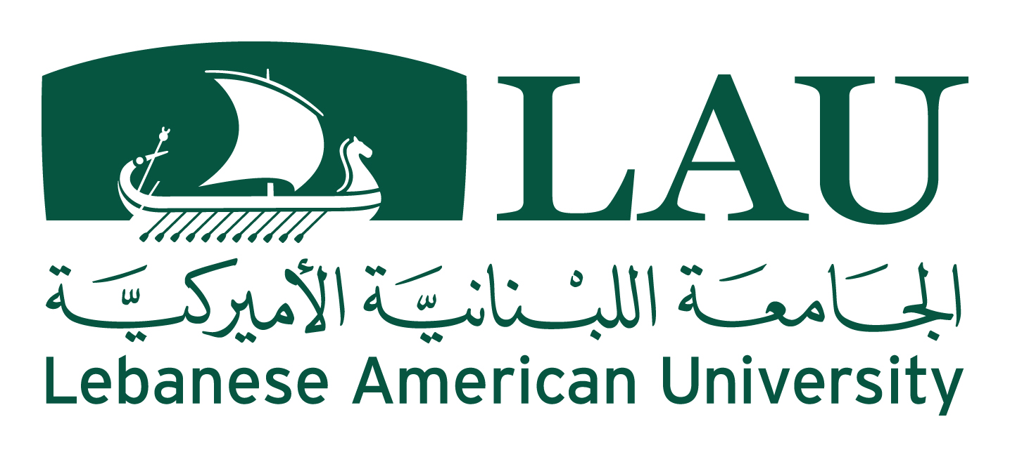
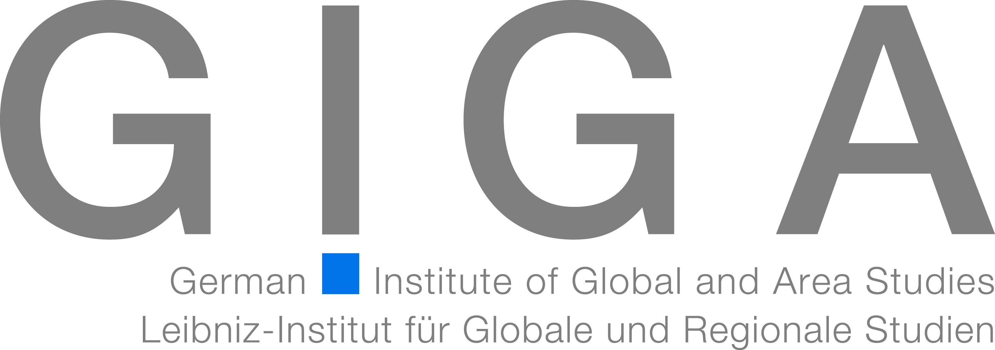

Conference 12.-13.11.2015, Byblos, LAU

Wars and Wars’ Ending in the Post-2011 Middle East

A Cooperation of GIGA, Hamburg, and LAU, Byblos

Outline
The conference shall address the following questions:
- How can we explain the increasing outbreak of wars in the region in the aftermath of the “Arab Spring”?
- What is novel in these wars compared to their precedents in the region?
- How is it possible to exit these wars and to prevent a further spillover of violence?
- What can we learn from former wars (e.g. the Lebanese Civil War) to end the recent ones?
The conference refers to a multidimensional analysis as it takes into consideration:
- Comparing cases locally, regionally and globally,
- Studying external interference and spillover effects
- Developing scenarios for conflict resolution.

12.11.2015
9.00-9.15

Welcome Note
Dr. Nashat Mansour (LAU) and Henner Fürtig (GIGA)

9.15-10.30

“Violent Dynamics and New Wars in the Middle East Since 2011” (Keynote Speech)
Maha Yahya (Carnegie, Beirut)

Coffee break 10.30-11.00
11.00-13.00

Introduction to the Conference
Stephan Rosiny and Marwan Rowayheb

Lebanon’s Civil War (1975-1990): Lessons for Current Events
Chair: Marwan Rowayheb

Lebanon: Genesis, Actors and Dynamics of the Lebanese Civil War
Paul Tabar (LAU, Beirut)

Lebanon’s Wars not Ending: External Actors and Regional Dynamics (1970-2015)
Walid Moubarak (LAU, Lebanon)

Interim Stabilization Arrangements in Lebanon: A Blueprint for Today’s Wars?
Erik Mohns, (Berghof Foundation, Berlin)

Iraq and Syria
14.00-17.00
Welcome Note by the German Ambassador Martin Huth
Chair: Stephan Rosiny

The Long Path of War in Iraq
Henner Fürtig (GIGA, Hamburg)

Iraq: Local and Regional Dynamics of War
Faleh Abd al-Jabar (Iraq Studies, Beirut)
Coffee break 15.00-15.30
Chair: Thomas Richter

Syria: The Security Dilemma of Religious Minorities
Leon Goldsmith (Sultan Qaboos University, Maskat)

Cross-Border Effects of the Syrian War
André Bank (GIGA, Hamburg)

On the Origins of ISIS: A Multivariate Model for Explaining the Emergence and Growth of the “Islamic State”
Sami Baroudy (LAU, Beirut)

13.11.2015

The Yemen-War 2015
Chair: André Bank
9.30-10.30

Genesis, Actors, and Dynamics of the Yemen Uprising and Escalation to War
Adam Baron (Sanaa Center for Strategic Studies, ECFR)

Why Did Saudi Arabia Go to War in Yemen?
May Darwich (GIGA, Hamburg)
Coffee break 10.30-11.00

Causes and Endings of Wars

Regional Conflict Patterns
Chair: Marwan Rowayheb
11.00-12.30

Geo-Strategic Dimensions and the Resource Curse of the Middle East
Thomas Richter (GIGA, Hamburg)

The Politicization of Sectarianism and Ethnicity: Lessons from Lebanon
Sami Ofeish (Balamand University, Balamand)

Migration and Conflict in the Post-2011 Landscape
Tamirace Fakhoury (LAU, Byblos)

Conflict Resolution (How to Exit Wars)
Chair: Tamirace Fakhoury
13.30-14.30

Power-sharing Arrangements for the Middle East
Stephan Rosiny (GIGA, Hamburg)

Mediation by Third Parties
Makram Ouaiss (LAU, Byblos)

