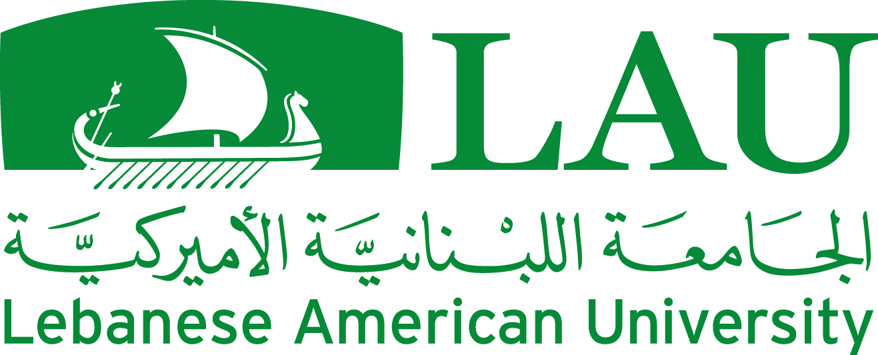
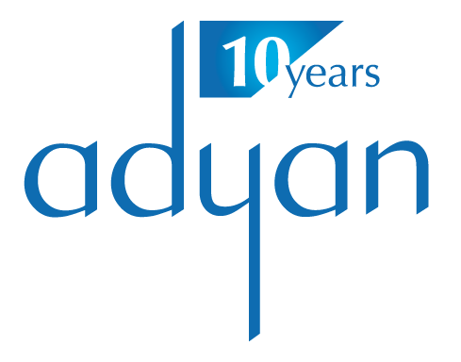
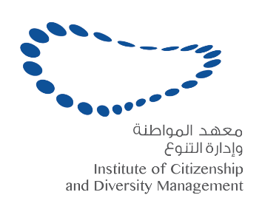

International Conference of
The Institute of Citizenship & Diversity Management at Adyan Foundation

In Partnership with the
Lebanese American University

With the support of
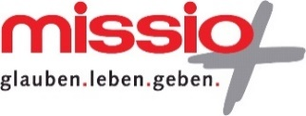

“Religious Freedom

and the Reconstruction of Citizenship”

Date: December 1 and 2, 2016
Location: Lebanese American University – Beirut – Lebanon
Conference languages: English and Arabic

Thursday December 1, 2016
9:30-10:30: Conference Opening- Irwin Theater

- Dr. George K. Najjar, Provost - Lebanese American University
- Reverend Jennie Nordin, Policy Advisor- Church of Sweden
- Dr. Matthias Vogt, Head of Foreign Department - Missio
- Dr. Nayla Tabbara, Institute of Citizenship and Diversity Management Director, Adyan Foundation
- Guest Speaker: Dr. Mohammad Sammak, General Secretary of the National Committee for Christian-Muslim Dialogue in Lebanon, Co-President of the World Council of Religions for Peace

10:30-11:15- Cocktail Reception

11:15- 13:00- Irwin Hall, 6th floor A, B, C
Panel 1: Citizenship, State culture and religious freedom

Panel Chair: Judge Abbas Halabi- President of the Arab Group for Christian Muslim Dialogue
- Dr. Samir Morcos, Member of the National Human Rights Council (Egypt) : “The ‘sacred’ and the ‘civil’ between constructive reconciliation and destructive enmity in the public sphere”
- Mr. Navid Baig, Vice-chair of Islamic-Christian Study Center (Denmark): “Denmark for Danes- questions of national identity, culture and religious freedom of the ’other'”
- Prof. Abdel Jabbar al Rifai, Director of the Center of Philosophy of Religion Studies (Iraq): Religious freedom in the horizon of traditional theology and jurisprudence
- Prof. Fadi Daou, President of Adyan Foundation (Lebanon): “The cultural dimensions of Religious Freedom and the passage from the Minorities’ paradigm to Citizenship Inclusive of diversity”

13:00-14:30- Lunch Break- Irwin Hall- Ground Floor- Faculty Lounge

14:30-16:00 - Irwin Hall, 6th floor, A, B, C
Panel 2: Local impact of international human rights instruments

Panel Chair: Dr. Lina Kreidie, Professor of Political Science at the American University of Beirut
- Esq. Ghassan Moukhaiber, Member of Parliament, member of Human Rights parliamentary committee (Lebanon): “Freedom of expression and religious freedom in Lebanese legislations”
- Esq. Saib Khidr Naif, Legal consultant and researcher on issues related to religious minorities in Iraq (Iraq): “Religious Freedom and international human rights instruments: an example from the reality of Iraq”
- Amb. Jean Christophe Peaucelle, Counselor for religious affairs, ministry of Foreign affairs and International Development (France)

16:16:30- Coffee Break

16:30-18:00- Irwin Hall, 6th floor, A, B, C
Panel 3: Freedom of speech, freedom of religion and the defamation law issue
Panel Chair: Dr. Tamirace Fakhoury- Professor of Political Science and International Affairs at the Lebanese American University
- Ms. Isabel Ruck, Expert Consultant at PHAROS Observatory of Religious and Cultural Pluralism (France): “Defending Religious Freedom: What’s in a label?”
- Esq. Salman Raja, Senior Advocate of the Supreme Court of Pakistan (Pakistan): “Jurisprudence in a time of violence”
- Dr. Nadia Abou Ghazi, Head of the Center for Political Research & Studies & Inter-cultural Dialogue, University of Cairo (Egypt): “The State between cultural policies and religious freedom”.
- Prof. Wajih Kanso, Professor of Philosophy at the Lebanese University (Lebanon) Reconsidering separation between public and religious domains
- Dr. Tarek Shaaban, Vice President of Al Azhar Observatory (Egypt): “Al-Azhar’s perspective and its efforts on the issue of freedom of expression and religious freedom and their impact on consolidating the notion of citizenship”

8:30 Conference Official Dinner

Friday December 2, 2016
9:00-11:00- Irwin Hall, 6th floor, A, B, C
Panel 4: Theological challenges of religious freedom

Panel Chair: Dr. Nayla Tabbara- Director of the Institute of Citizenship and Diversity Management at Adyan Foundation
- Prof. Armina Omerika, Professor of History of Ideas of Islam, Goethe University Frankfurt (Germany): “Challenges of negative freedom of religion (freedom from religion) for today’s Islamic theology”
- Prof. Gwen Griffith-Dickson, Director of The Lokahi Foundation (UK): “Theological Flashpoints in Religious Freedom”
- Prof. Amer Al Hafi, Professor of Islamic Studies and Comparative religion at Aal al Bayt University (Jordan) : “Religious freedom between the Qur’anic text and the current reality”
- Sayyid Jawad al Khoei, Professor at the Islamic Hawza in Najaf (Iraq): “The Najaf school’s view on Religious Freedom in Islam”

11:00-11:30 Coffee Break

11:30-13:30 - Irwin Hall, 6th floor, A, B, C
Panel 5: Religion and religious diversity management in the public sphere

Panel Chair: Dr. Marwan Rowayheb- Chairperson of the Department of Social Sciences at the Lebanese American University

- Fr. Adrien Sawadogo, Director of the Institute of Islamo-Christian Formation (Burkina Faso- Mali): "Religious diversity in sub-Saharan Africa, a reality that is put to the test (Mali, Burkina-Faso and Côte d’Ivoire)"
- Prof. Sami Baroudi, Professor of Political Science, Lebanese American University (Lebanon) : “The Status of Religious Minorities in the Discourses of Contemporary Islamists: The Limits to a Religiously-Based Construction of citizenship”
- Prof. Amel Grami, Professor of Islamology and Gender Studies at the University of Mannouba (Tunis): “On the management of religious diversity in the public sphere: a reading of the Tunisian experience”
- Dr. Brian Grim, President of Religious Freedom and Business Foundation (USA): “Empowerment-Plus Interfaith Initiative to Foster Social Cohesion and Enterprise”

13:30-15:00- Lunch Break- Irwin Hall- Ground Floor- Faculty Lounge

15:00-16:00- Irwin Hall, 6th floor, A, B, C
Panel 6: Religious freedom and Education

Panel Chair: Rev. Jennie Nordin - Policy Advisor at the Church of Sweden
- Prof. Joseph Maalouf, Professor of Philosophy at the Lebanese University (Lebanon): “Training on objectivity in approaching intellectual issues”
- Dr. Wafaa Alcherbiny, Faculty of Economics and Political Sciences, University of Cairo (Egypt):“Education and religious freedom from “teaching citizenship” to “politicizing diversity””
- Ms. Mosarrat Qadeem, co-founder of PAIMAN Alumni Trust (Pakistan): “Inclusive Peace Education for rebuilding citizenship in Pakistan”

16:00-16:30 Break

16:30-18:00- Irwin Hall, 6th floor, A, B, C
Panel 7: Religious Freedom and Media

Panel Chair: Mr. Bassam Abu Zeid- Reporter at LBCI news
- Ms. Reem Khalifa, independent Bahraini journalist, founding member of the editorial team of Al Wasat newspaper (Bahrain): “Religious Freedom and Media: the case of Bahrain”
- Dr. Ahmad Zohbi, Editor in chief of Lebanon 24, Professor of Political Science and Islamic Studies (Lebanon): “On the trilogy of Freedom, Citizenship and Diversity: How can the media build a culture of tolerance?”
- Mr. Mohamad Al Arab (ART-Al Fajr Radio-Lebanon) – Ms. Sandy Habashneh (Jordanian TV- Jordan)- Mr. Mohammad al Moumin (Al-Ghadir TV-Iraq): “The Code of conduct for media coverage of issues related to freedom of religion and belief”

18:00-18:30 -- Irwin Hall, 6th floor, A, B, C

Closing

Closing remarks
- Reverend Jennie Nordin, Policy Advisor, Church of Sweden
- Dr. Matthias Vogt, Head of Foreign Department, Missio
- Dr. Marwan Rowayheb, Chair of the Department of Social Studies, Lebanese American University
- Dr. Nayla Tabbara, Director of the Institute of Citizenship and Diversity Management, Adyan

