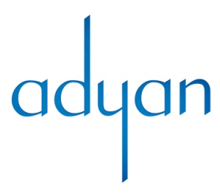
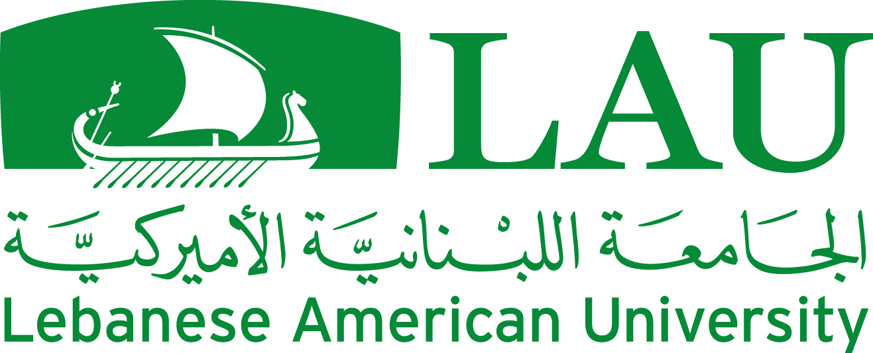

International conference on

Religions and Political Values
Date: 26-28 November 2014
Venue: Lebanese American University – Byblos- Lebanon
(Conference in English and Arabic - Simultaneous translation is provided)

Organized by
Adyan Foundation

In partnership with
The Lebanese American University
Konrad Adenauer Stiftung
Institute of Missiology – Missio
Religions for Peace-MENA council
Catholic Relief Services

Program
Wednesday 26 November (5:00-7:00)
Public Official Opening
(Hilton Hotel - Beirut)
5:00 Welcoming guests
5:30 Lebanese National Anthem

Welcome address by the Conference Coordinator
Dr. Nayla Tabbara, Director of the Cross-Cultural Studies Department, Adyan Foundation

Address of the Lebanese American University
Dr. Georges Najjar, Provost

Address of Konrad Adenauer Stiftung
Mr. Peter Rimmele, Resident Representative in Lebanon

Address of Religions for Peace
Dr. William Vendley, Secretary General

Ceremony of Presentation of Adyan’s 2014 Spiritual Solidarity Award
to departed Sayyid Hani Fahs and HE Shaykh Abdullah Bin Bayyah

Address of Adyan Foundation
Prof. Fadi Daou, Chairperson

Address of the Conference Guest Speaker
His Eminence Cardinal Mar Bechara Boutros al Raï, Maronite Patriarch of Antioch and all the East

Program presented by Ms. Tania Awad Ghorra, Media Professional
Cocktail Reception

Thursday 27 November
(LAU – Byblos)
Panel 1: 9:00- 11:00
Ethics between religion and politics

Panel Chair: Dr. Nayla Tabbara
Dr. Stefan Friedrich (Germany): Plural secular societies and value-based politics
Dr. Nayla Abi Nader (Lebanon): “Islam, Ethics and Politics”: a reading of Mohammad Arkoun’s thought
Dr. Theo Brinkel (Netherlands): The relevance of faith-inspired politics for democracy and justice
Dr. Wajiha al Baharna (Bahrain): Religion and politics, two sides of the same coin: a values-based approach

Panel 2: 11:30-1:30
Contemporary challenges for religion and political values
Panel Chair: Dr. Marwan Rowayheb

Prof. Joseph Maalouf (Lebanon): No political continuation in the Arab world without a minimum of ethical and religious understanding: an approach through Hans Kung and Amin Maalouf
Prof. Tayyib Tizini (Syria): Does the unification of the world go through ISIS?
Prof. Alicia Cabezudo (Argentina/Spain): Religions and Political Values: a Necessary Dialogue in Education
Dr. Makram Ouaiss (Lebanon): When Official Tracks Fail, can Non-Official Tracks Reconcile Religion and Politics in Post-Conflict Countries? The Case of Lebanon

Panel 3: 3:00-5:30
The relation between religion and politics
as a values reshaping dynamic

Panel Chair: Prof. Fadi Daou
Prof. Wajih Kanso (Lebanon): Role of politics in the formation of Religious Values
Dr. Ali Khalife (Lebanon): Political values from the point of view of Islam and Christianity
Prof. Abdel Jabbar al Rifai (Iraq): What State without spiritual life and ethical values?
Dr. Afag Mohammad Sadeq (Sudan): The political role of sufi groups: the example of Sudan

Friday 28 November 2014
(LAU – Byblos)
Panel 4 – 9:00- 11:00
Values questioning political islam
Panel Chair: Dr. Mohammad Sammak
Mr. Qassem Kassir (Lebanon): Islamist movements and political values: the double standards between theory and practice in regards to democracy and good governance
Dr. Michael Driessen (US-Italy): Comparing Post-Secularism and Post-Islamism in Catholic and Muslim Contexts
Shaykh Muhammad Abu Zayd (Lebanon): Religion and power in the Syrian context: the example of Marwan Hadid and Jawdat Said
Dr. Sami Baroudi (Lebanon): Moderate Sunni Islam and International Relations: The discourses of two leading contemporary Islamic thinkers (Qaradawi and Zuhaili)

Group photo

Panel 5 -11:30-1:30
Political values for inclusive citizenship
Panel chair: Prof. Harald Suermann
Revd. Canon Alistair MacDonald Radcliff (UK): Can citizenship be a political value for social cohesion and interfaith harmony?
Prof. Patrice Brodeur (Canada-Austria): Dialogue as a global political value
Fr. Dr. Bassem Rai (Lebanon): Religious Freedom and the freedom of religion
Mr. Georges Fahmi (Egypt)

Panel 6 -3:00-4:30
Spiritual values for politics of peace

Panel Chair: Dr. William Vendley
Prof. Hadi Adanali (Turkey): Empathy as a Religious and Political Value
Dr. Federico di Leo (Italy): Confidence, service and dialogue: Religion and political issues
Mr. Ali Gohar (Pakistan): The non-violent movement of the servants of God under the Leadership of Bacha Khan (1928-40) (TBC)
Dr. Mohammad Bechari (Morocco/France) (TBC)

Evaluations and Conclusions Panel:
5:00-6:00
Conclusive comments
Prof. Harald Suermann- Missio
Dr. Nayla Tabbara- Conference Coordinator- Adyan

